JSC
各種申し込みフォーム URLおよびQRコード一覧

●JSC禁忌症講座オンライン受講の申し込み
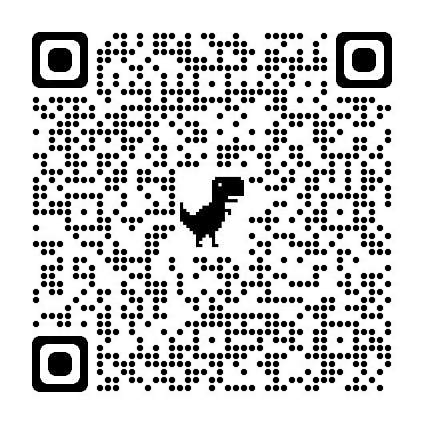
https://docs.google.com/forms/d/e/1FAIpQLSdIev5NeWDpS7kI-BEr9jo9Kp-WK72y0k-Tg9WiuvjOuaE9cA/viewform

●JSC栄養学セミナー
https://docs.google.com/forms/d/e/1FAIpQLSfm-lCMx_jRC2g_pGmn5RByIGt9K7dGbhP73IbKWX5PLUMMSQ/viewform
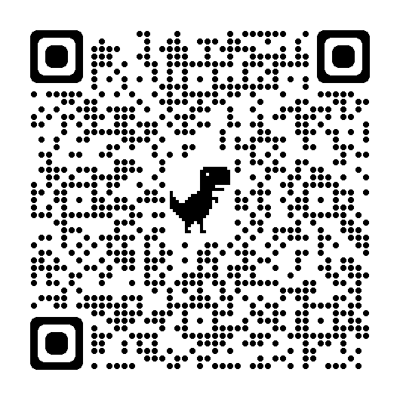

●JSC指定院 認可申請
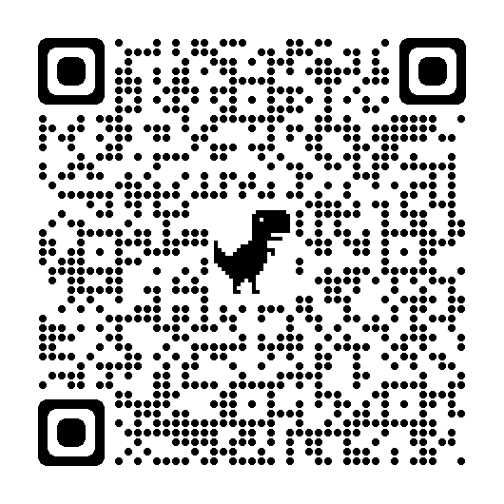
https://docs.google.com/forms/d/e/1FAIpQLSerJCcHNdrJiCTsKeO0Bsd5-0ElgnlohTHMDtHjmQlLGKNIFw/viewform

●JSC単位申請フォーム
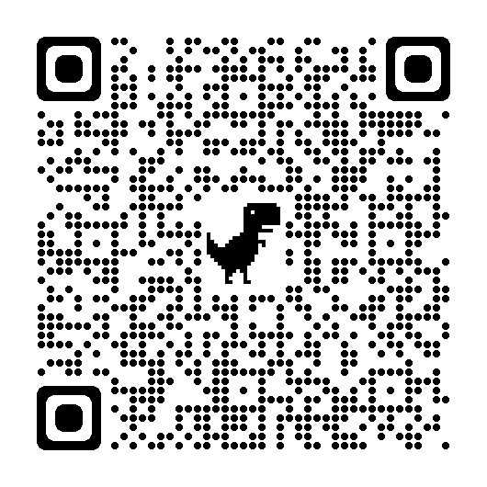
https://docs.google.com/forms/d/e/1FAIpQLSeZsQoWoUXJio5AYlZz8kaBxGYwr4SnLiLxQkDvH0hlbOzw1A/viewform

●JSCの賠償責任保険の申し込み
https://docs.google.com/forms/d/e/1FAIpQLSc-SFqNxGNDXx8W109iRqH63TGFCidPB3hUG3S0Ke4Tw9XPaA/viewform
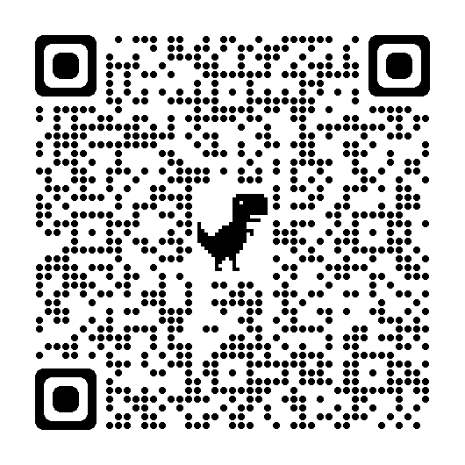

●JSC入会申し込み書
https://docs.google.com/forms/d/e/1FAIpQLSfye96_k_O9pOnV1w-nZHHEDWq_VuvC6A2zsVLdzH718Cw7Rg/viewform
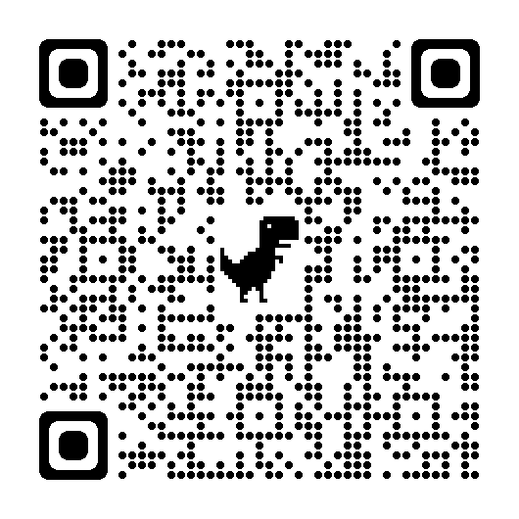

●メール質問申込書
https://docs.google.com/forms/d/e/1FAIpQLSd3R789R8O8IAZNnFxk0MmceGKU_rTR8OUuM7EucZtmAyG-UQ/viewform
